**1. What is the question?**

I used idiosyncratic variation in rainfall over a woman’s life cycle to investigate the relationship between marriage age and income shock in a setting where the bride price is customary.

What is the relationship between income shock and marriage age when taking bride price into consideration?

**2.Why is it important (why should we care)?**

--early marriage is still a common practice in our country, especially among girls. There many woman married before the legal marry age 20.

--The relationship between female early marriage and poor physical and socioeconomic outcomes is well established in the literature.

-- Child marriage is associated with lower educational attainment, lower use of preventive health care services, lower bargaining power within the household, physical abuse and domestic violence

-- little research has examined the important question of why such a practice is still so widespread and what might be effective policies to reduce it.

**3. What do we know already from the literature?**

文献探讨：

Early marriage and woman well being

Rainfall shock and income shock—

The use of weather variations as proxy for income shocks in developing countries is widespread in the literature. See Miguel, Satyanath and Sergenti (2004), Bj¨orkman-Nyqvist (2013), Dustmann, Fasani and Speciale (2017) among others.

Income shock and early marriage

**4. What will this paper add that is new**

In China using the data from CHARLS

**5. How does the paper answer its question**

**The decision model：**

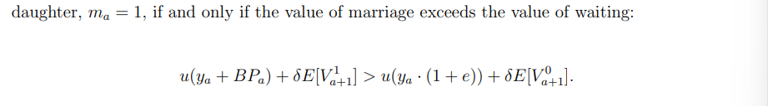

Prediction：marry if BP>e( captures the proportional contribution provided or the cost imposed by a daughter on the household consumption when she is living with her parents)

**Data and descriptive statistics:**

**1.marriage and bride price**

Marriage data from CHARLS: 受访者的孩子相关信息

Bride price data 计算了bgift from male

F1—distribution of ages marriage separately for men and women

As shown in the graph, a sizable portion of women marry during their teenage years, while typically fewer men do so.

The key in my analysis is the pride price. Show 一副中国彩礼的表格or 地图

T2 show the demographic information in our sample—

--live in urban or village?

--Parents education

--main job?

**2.rainfall shocks—droughts**

Rainfall data from NOAA-CPC：

National Oceanic and Atmospheric Administration

NOAA-CPC

I therefore use estimates on rainfall precipitations as a source of exogenous variation for income shocks.

计算城市每年的平均降水量—得出城市平均降水水平—计算每年与均值的差值，得出干旱的指标。

将该数值匹配到那个人age的年份，比如18岁时是2000年，就匹配2000年该城市的shock。上一年的shock会对今年产生影响

**Empirical Strategy**

To estimate the effect of a negative income shock of a household on their children’s marriage age, I exploit the exogenous variation in weather shocks across cities

Here is the model:

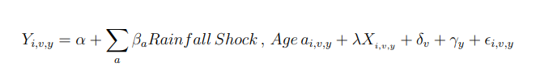

**6. What does the paper find?**

**Empirical Results:**

**1.marriage age and income shocks**

**2.marriage age and income shocks by bride price’s amount**

Overall, these findings point in the direction of interpreting the bride price as a source of insurance for households exposed to income shocks in the presence of capital markets imperfections.

**Conclusions:**

I find that adverse shocks during teenage years increase the probability of early marriages.(decrease the marriage age)

Cash transfers, both conditional on avoiding child marriage and unconditional, can reduce early marriages, especially when they target low-income households